SS8 – Highmid05
- Belief and Devotion

Belief and Devotion

The people of the middle ages were deeply religious

They saw evidence of God’s hand in their everyday lives, brining them success or failure, sickness or health, rain or drought.

The Church reinforced the idea that people should accept and be happy with their position in life (either as a noble or a commoner) as it was all part of God’s plan.

Between 800 and 1300 the Catholic Church was the only religious institution in Western Europe and was therefore very influential and very powerful.

The Church was also very wealthy because of its land holdings and the church tithe or tax on the commoners.

Commoners who were both inspired and who wanted to improve their lifestyle, either entered the church as a monk or a nun.
SS8 – Highmid05
- Belief and Devotion

Belief and Devotion

Directions: Read pages 54-56 in your text Pathways - Civilization Through Time and
answer the following questions on a separate piece of paper.

1. Provide definitions for the following vocabulary words;

skeptical of to excommunicate relic
tithe ecclesiastical

2. Answer the following questions using COMPLETE SENTENCES;

- Describe how the Catholic Church became such a powerful institution in the Middle Ages. (2 marks for quality of answer)

- Explain what it meant to be excommunicated from the Church. (2 marks for quality of answer)

- In what ways was the Church’s influence over people a positive thing? A negative thing? (2 marks for quality of answer)
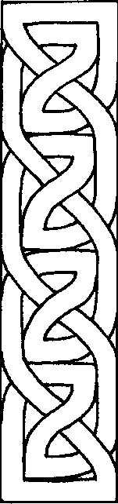

3. Celtic Art - Religious art played a large role in middle ages. The Celts of Northern Britain incorporated many drawings of religious crosses (see picture to the right) into their particular type of “weaving art”. This “weaving art” can take the shape of most anything or is often seen as a border (on the left) to other types of art. The key to making quality Celtic art is to follow a few basic steps;

- For the first time, us a piece of dot graph paper like the one found attached.
- Connect the small dots (using a light pencil) to form crosses.
- After rounding the edges, weave your light pencil lines over and under one another to create the illusion of a continuous line.
For more detailed instructions see below

You are to create your own Celtic, box, border or art using
any shape you wish. (5 marks for quality of effort)

Total: ____/ 16

SS8 – Highmid05
- Belief and Devotion

Celtic Art

Mark off a portion of your graph paper, at least 5 big dots and 4 little dots across. Mark the same distance down (5 big and 4 little dots) so you have an even square. Each small dot is going to be an intersection where two "ropes" of knot are going to cross over each other. Put a double lined "X" over a little dot on your graph paper. It should look like a tipped over tic-tac-toe board.
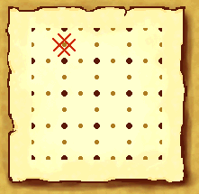

Continue drawing your "X" over each little knot up to your border. Do not "X" the little dots that lie right on your border line, just those that fall within the border. Your big dots never get crossed over. Think of the big dots as posts that the knot must bend around to follow its path. You'll find that your crisscrosses will meet up on the diagonal, which is a good thing. If you are making a very large knot, you can make this step go faster by using a ruler and just drawing a line along the diagonal of the little dots. However, when you begin to make really complicated knots, the "crisscross" method keeps things from getting tangled up.
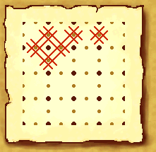
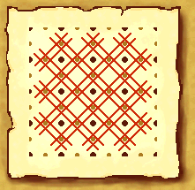
At this point, you should have an "X" over every little dot in your marked off area. You can use your big dots to help gauge the width of your knot bands as you draw your knot. The band should be the same distance from the big dots as you go around. Whether you want thin spaghetti strands overlapping, or thick noodles, is up to your personal taste. However, take care to keep the thickness the same throughout the knot, whatever you choose, because usually the knot is supposed to be one continuous strand, with no beginning or end.

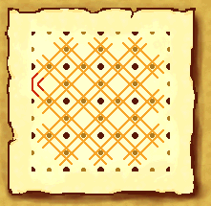
Now that we have all the little dots crisscrossed, we must join the knot lines along the sides, top and bottom of the marked off area. Find where two lines branch out from the body of the knot, angling towards each other. Make a double lined bend to connect them. You may vary the sharpness of the turn to suit your tastes, from a 90 degree angle to a soft, round curve. There are a lot of variations you can do by varying the angle of the bends.
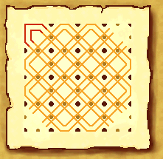
Now all the loose ends on the knot should be joined, except for at the corners. Add the caps on the corners of the knot. This part is easy, as there are only two lines in each corner to join! As with the sides, the way you join the two strands is up to you, and again you may want to experiment with rounder corners or pointy corners. Or you can make a corner that is shaped like a flower petal, where it flares out from the last crisscross and then in again to join to a point.

Now all your corners should also be joined. As you check over your knot, there should not be any loose ends left at all, on the sides or on the corners.
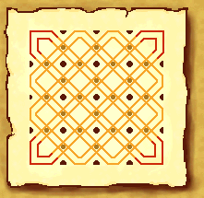

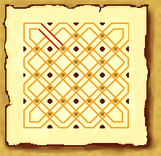
When the caps are on all our corners we will begin to make the lines of our knot interweave. Each line as it interweaves must go over, and then under, any other line it intersects as you follow its path. This makes any line go over-under-over-under the other lines in the knot. It is very important that this pattern is kept, or you're knot will have very obvious gaps where there'll be two overs or two unders in a row. To start your over/unders, pick a point of intersection on your knot. It doesn't matter where. At this intersection, erase part of the double lines to one of the ropes of knot, making the illusion of one rope passing over the other.

Continue to follow that one rope of knot, erasing as you go, alternating whether it goes over or under the next rope it meets. If you reach the end of the knots path, and there are still lines of over/under that haven't been erased, don't worry. This just means that your knot actually has more than one continuous strand of rope in it. Simply pick an unerased intersection and look at the other ones around it. If the rope leading into the intersection has just come from under another rope, you need to erase your lines so it now passes over this one. It should then continue to pass under the next line.
