Math 7 – Unit 7.5
- Interpreting Circle Graphs

7.5 – Interpreting Circle Graphs

A circle graph is sometimes called a pie graph. It shows how a total amount has been divided into parts according to percents. The percents of a circle graph always add up to 100%.

The following circle graph shows the inventory at Future Shop, an electronics superstore.
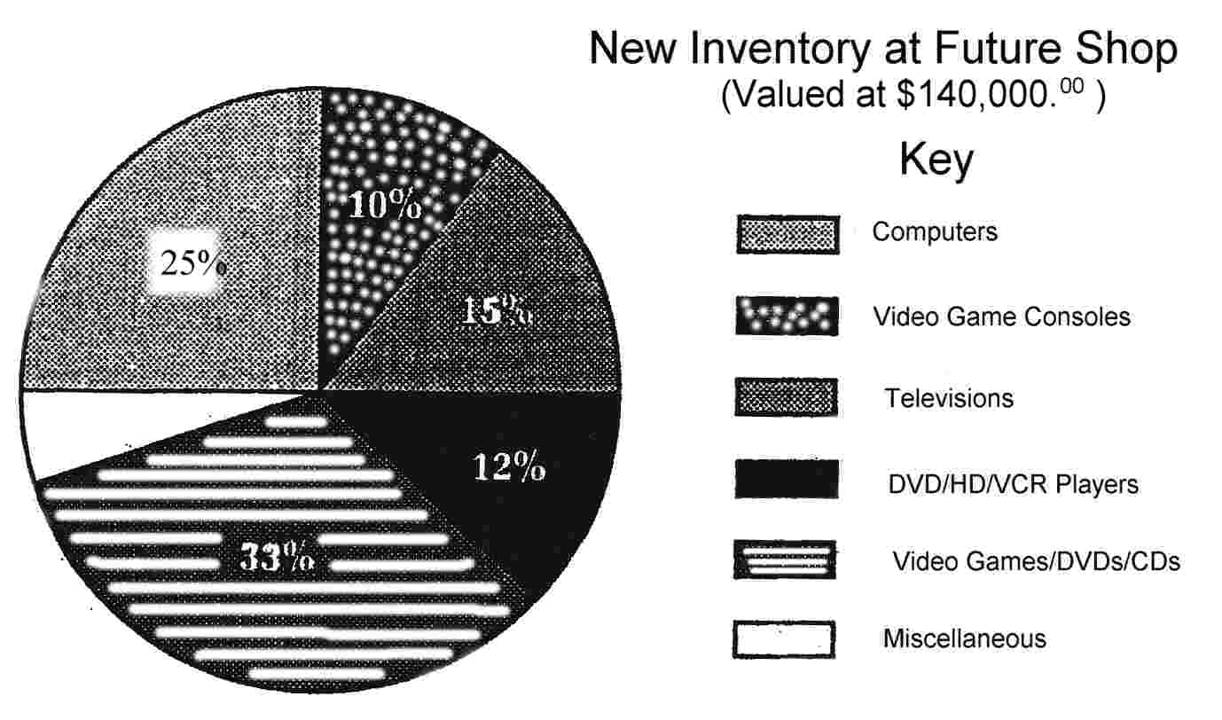

Directions: Using the information provided in the circle graph above answer the following questions;

1. | What percent of the new inventory at Future Shop are Televisions?
2. | What percent of the new inventory at Future Shop are Video Game Consoles?
3. | What percent of the new inventory at Future Shop are Computers?
4. | What percent of the new inventory at Future Shop are DVD/HD/VCR Players?
5. | How much of the new inventory can be classified as Video Games, DVDs or CDs?
6. | What category would you think MP3 players, Flash Drives and Cameras fall under?
7. | What percent of Future Shop’s inventory can be classified as “Miscellaneous”?

Calculating Amounts from Circle Graph Percents

Because circle graphs are expressed as percents of an amount, the specific amount can be calculated by multiplying the decimal form of the percent (always use the decimal form of a percent when you use calculations) by the total amount the pie graph is representing. For example;

What is the new inventory dollar amount that Future Shop has in computer stock?
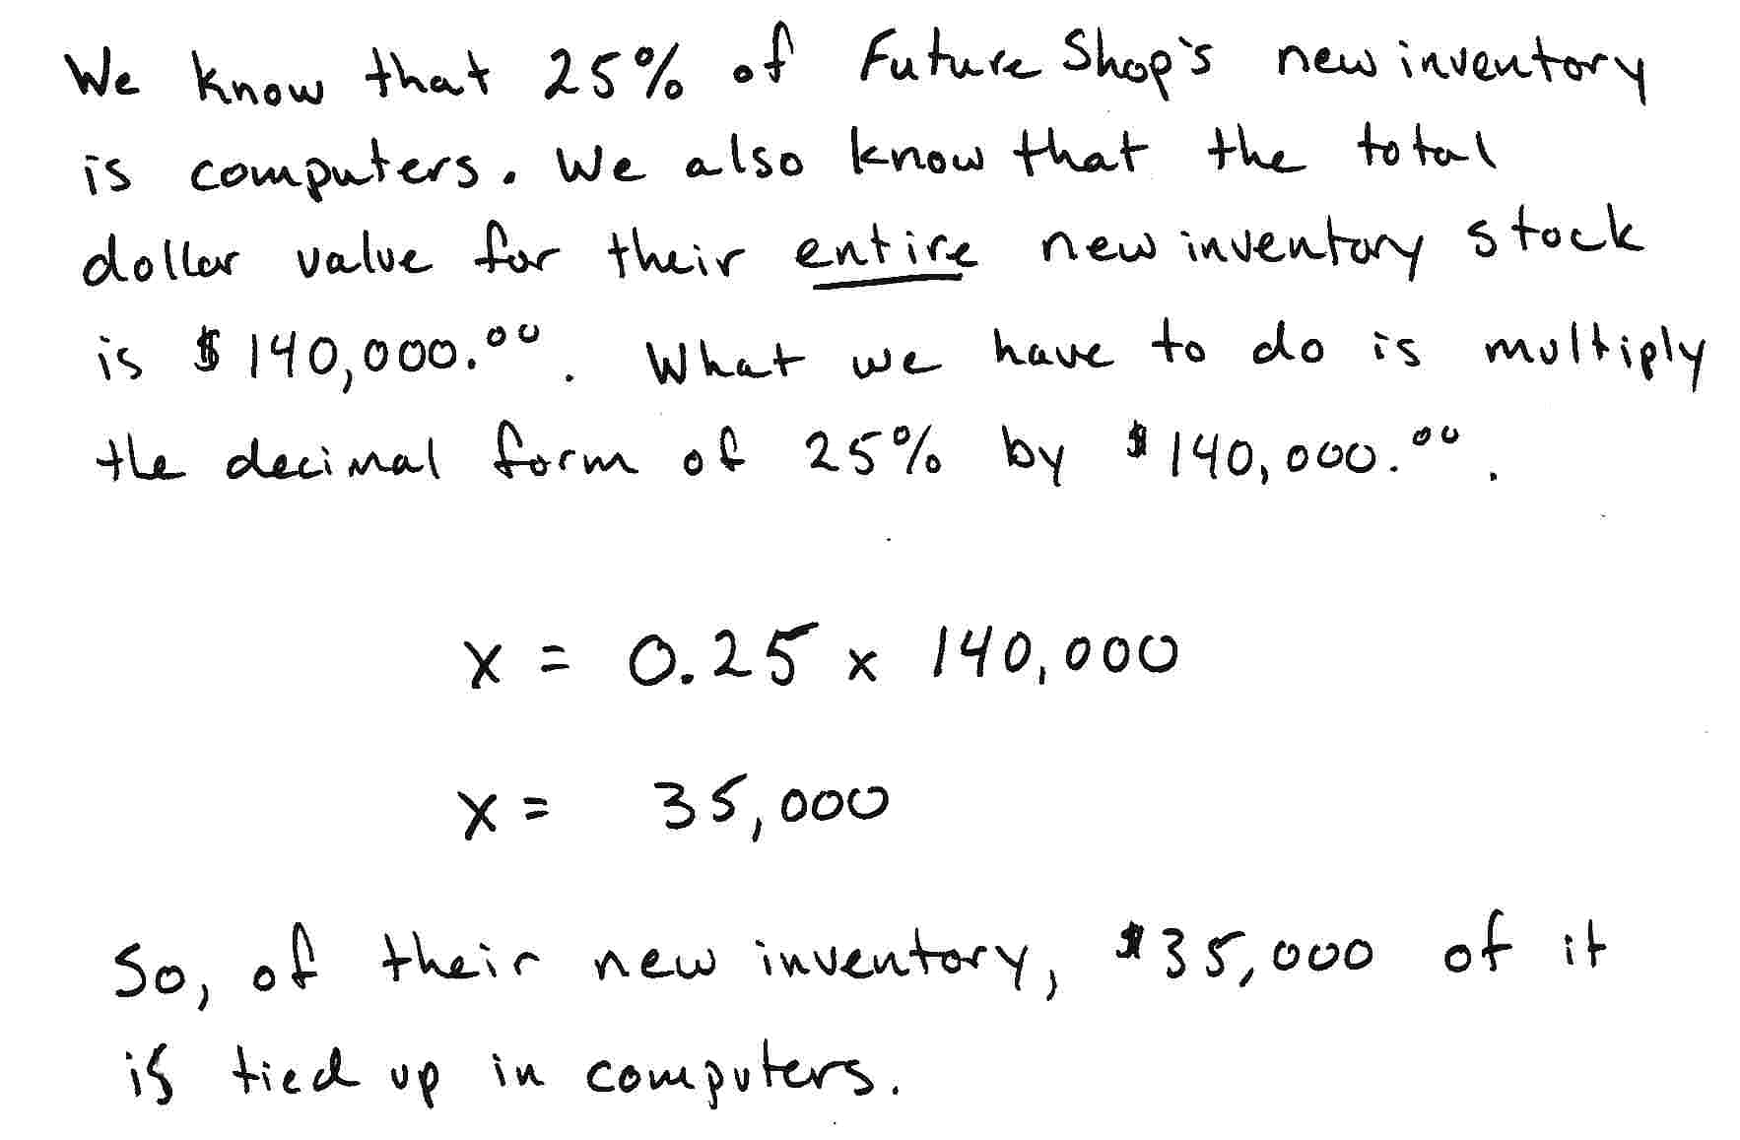
Solution:

Your turn…

Directions: Use the following table to help you calculate how much of their total of $140,000.⁰⁰ worth of inventory does Future Shop have tied up in the following categories. The first one has been done for you.

Inventory Category | Percent | Decimal | Calculation | Dollar Amount
Computers | 25% | 0.25 | 0.25 x 140,000.⁰⁰ = | 35,000.⁰⁰
Video Game Consoles

Televisions

DVD/HD/VCR Players

Video Games/DVD/CD’s

Directions: Assuming that Pizza Hut sells 350 pizzas a night, calculate exactly how many of each pizzas they sold.

Types of Pizza | Percent | Decimal | Calculation | Number of Pizzas
Supreme

Pepperoni

Cheese

Sausage

Directions: Look at the following circle graph that represents a high school survey on student’s favorite flavor of ice cream, and answer the following questions.
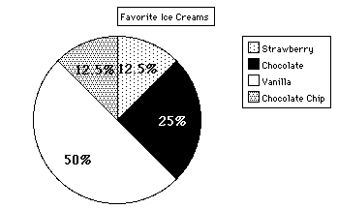

- Which two flavors together, make up ¾ of the student’s choices?

____________________ ____________________

- What is the overwhelming flavor favorite of the students?

_____________________

- If 200 students were surveyed. How many students like; (SHOW YOUR CALCULATIONS!)

- Strawberry

- Chocolate

- Vanilla

- If the entire student body of the school was 500, how many would you expect would like chocolate chip? SHOW ALL YOUR CALCULATIONS!!

Directions: Complete the blank circle graph outline using the information provided, then answer the following questions.

The following information was collected after a field trip to the zoo. Students were asked’ “What is your favorite animal at the zoo?”

1. | Fill in the pie graph with the appropriate animal. Using colors can help.
2. | How many student’s were surveyed?
3. | How many of the total liked lions?
4. | What percent of the students liked giraffes?
5. | What percent of the students liked monkeys?
6. | What was the most popular animal?
7. | What percent of the student’s liked pandas?

Directions: Complete the following worksheet.
