Math 7 – Unit 7.4
- Circumference and Area of a Circle

7.4 – Circumference and Area of a Circle

Like perimeter, the circumference of a circle is the distance AROUND the outside. Unlike an object with straight side, the circumference of a circle is more difficult to calculate, in fact, you need a formula to solve the circumference of a circle.

In order to use the formula for the circumference of a circle, you have to know two terms as they relate to a circle; the diameter and the radius. The diameter is the straight line, from one side of the circle through the next, straight through the middle. The radius is a straight line, staring from the middle and extending out to a side.
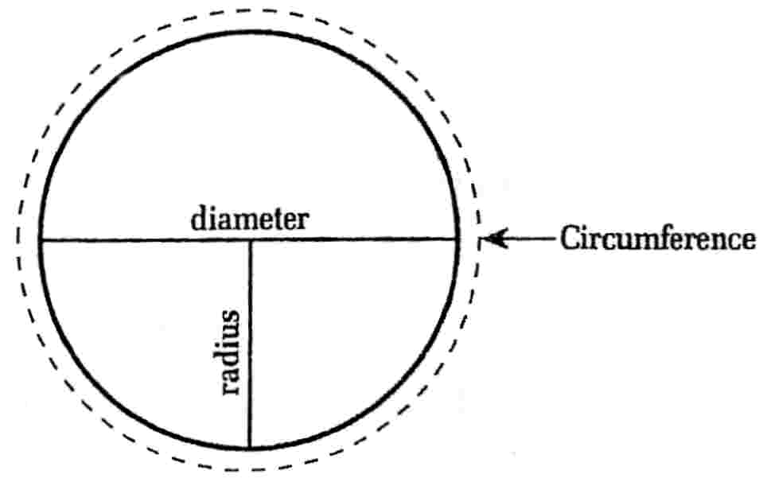

In order to solve the problem of calculating the circumference of a circle we have to use a very specific ratio which in this case is called pi and is represented by the Greek symbol;
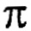

Pi has a value of 3.14

Because the radius is half the size of the diameter, the formula for the circumference (c) can either be expressed using radius (r) or diameter (d);

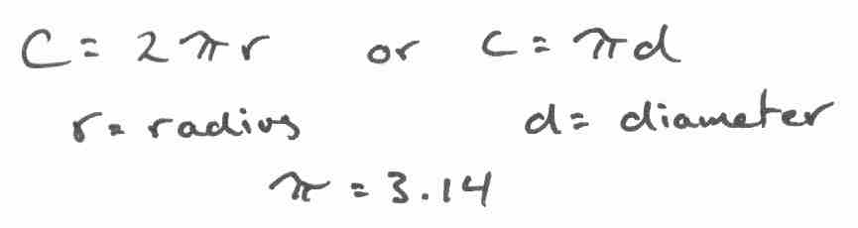

Let’s look at some examples using the diameter circumference formula;

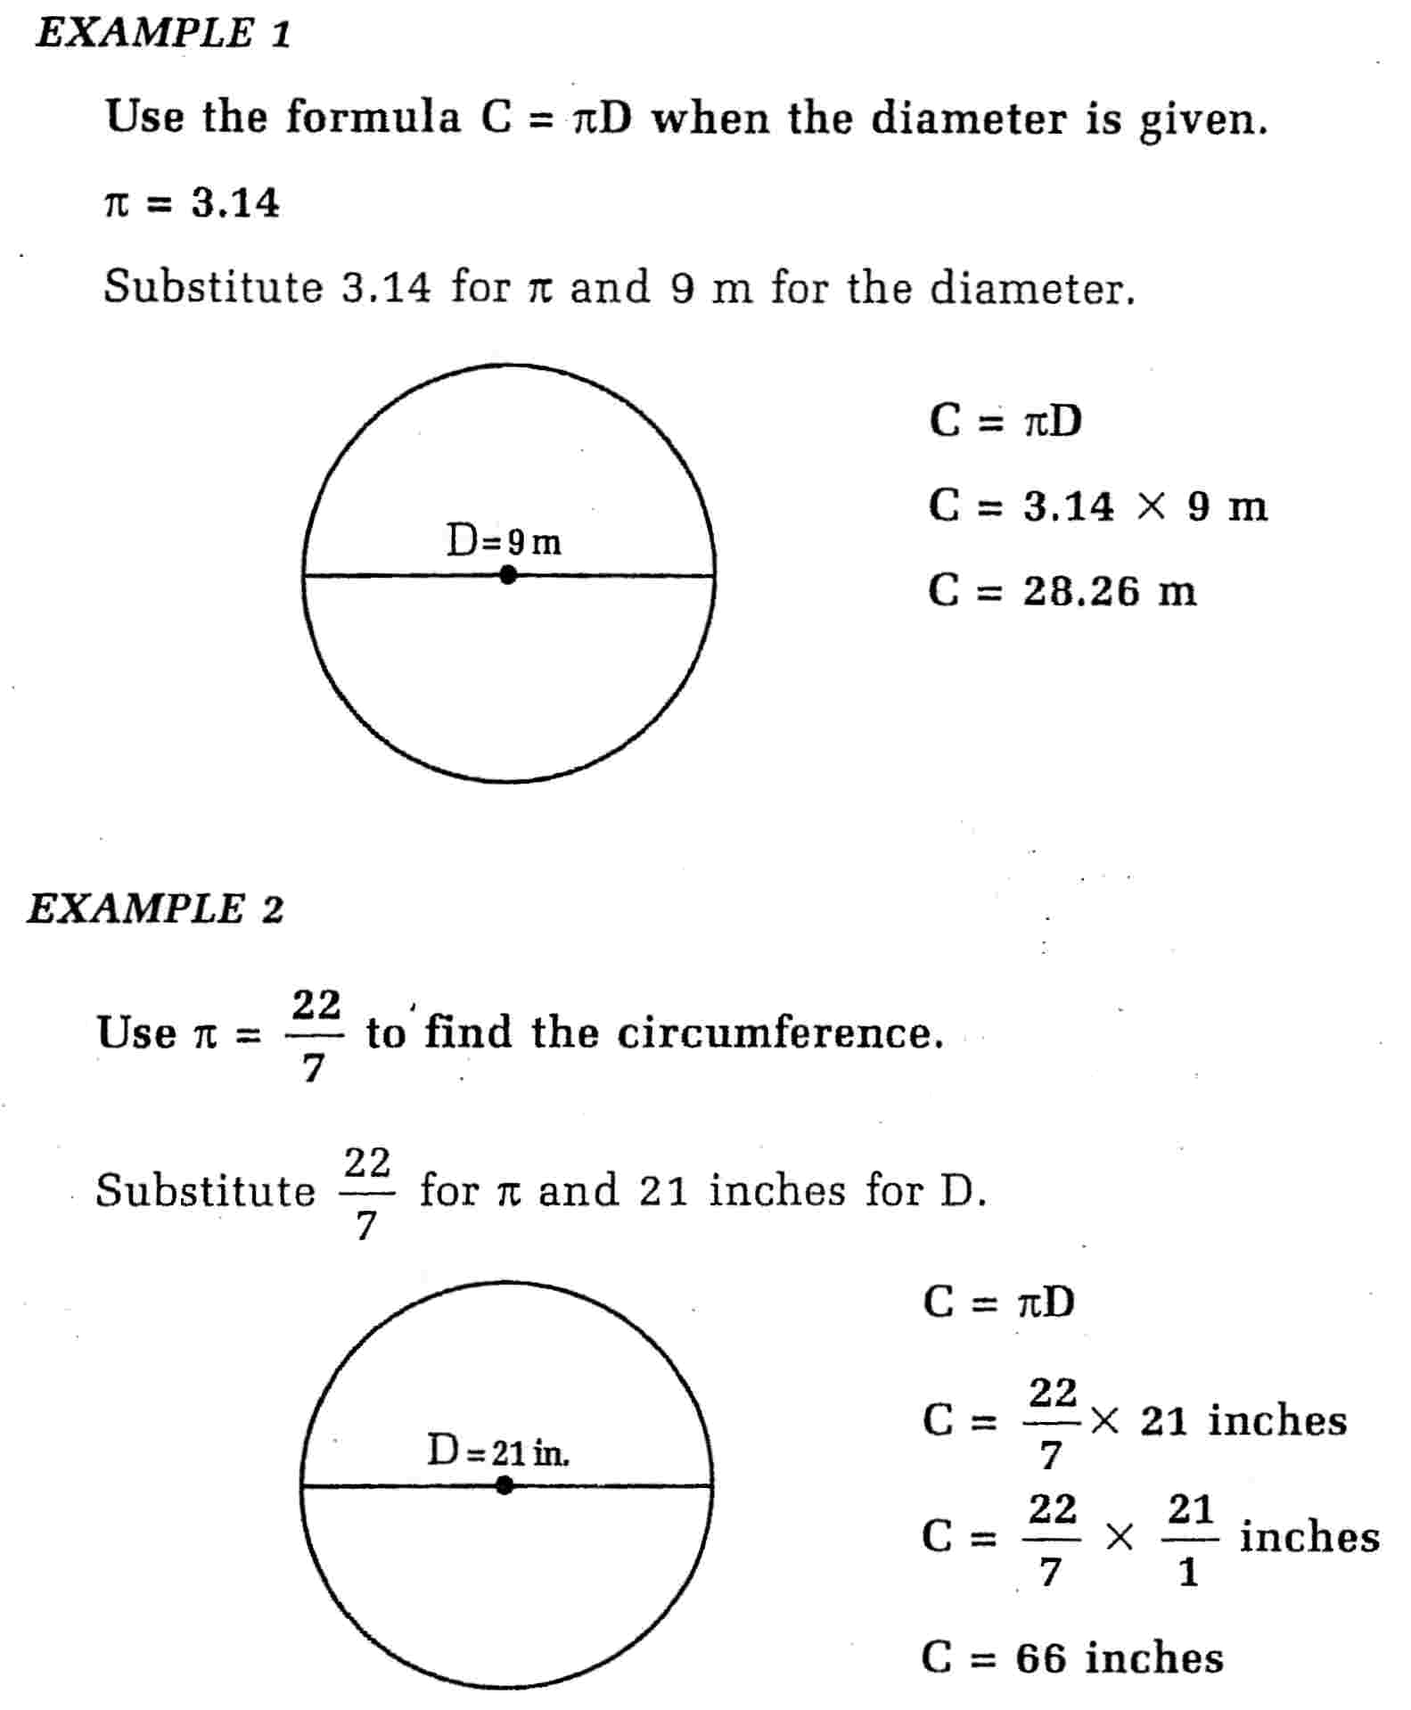

Your turn…

Directions: Find the circumference of the following circles. SHOW ALL YOUR WORK FOR FULL MARKS!!!

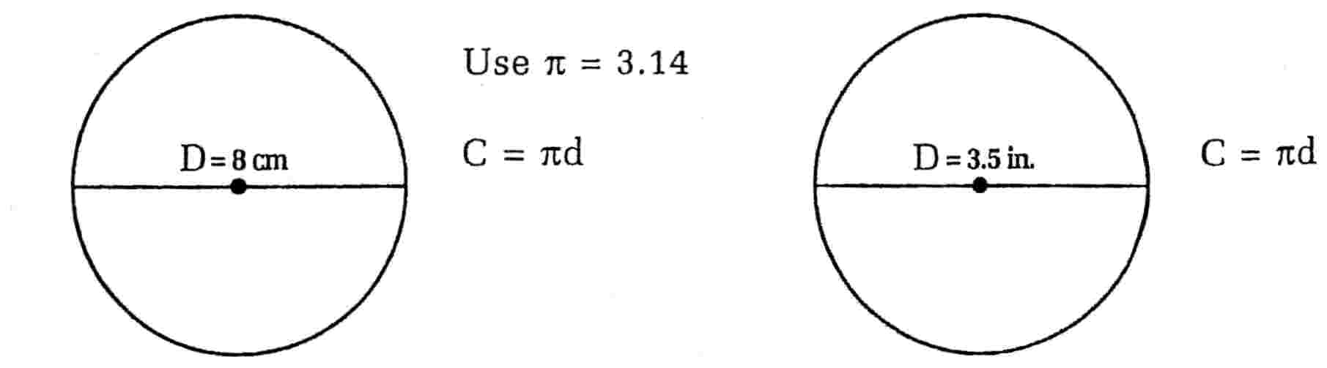

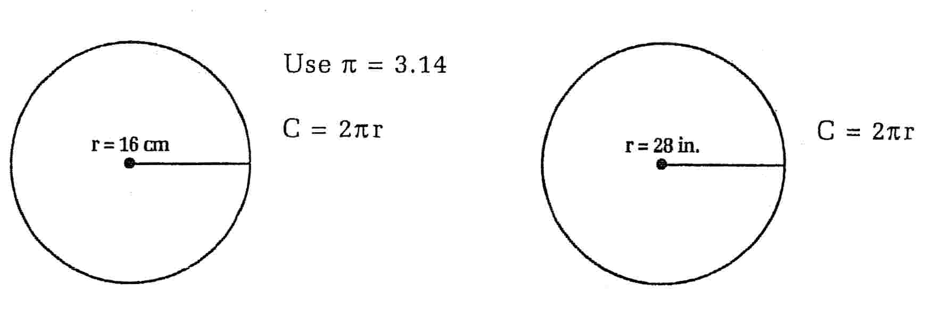
Directions: Solve the following word problems. Sketch out a diagram if necessary. When asked, start with your formula and then SHOW ALL YOUR WORK!!!

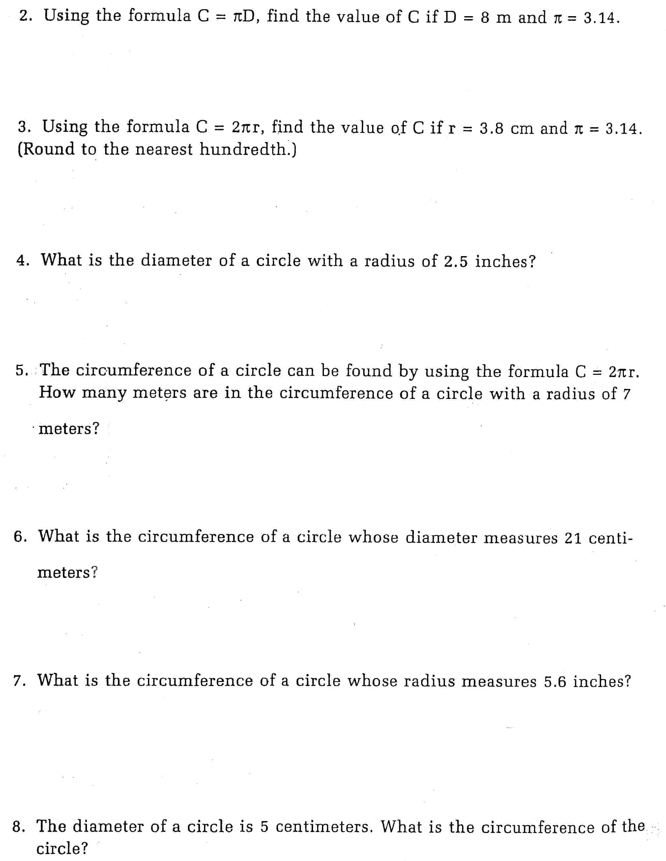

Area of a Circle

The area of a circle is simply the amount of space contained within a circle. Like all other area questions, answers are ALWAYS in “units squared” such as cm² or in.². Study the example questions provided below;

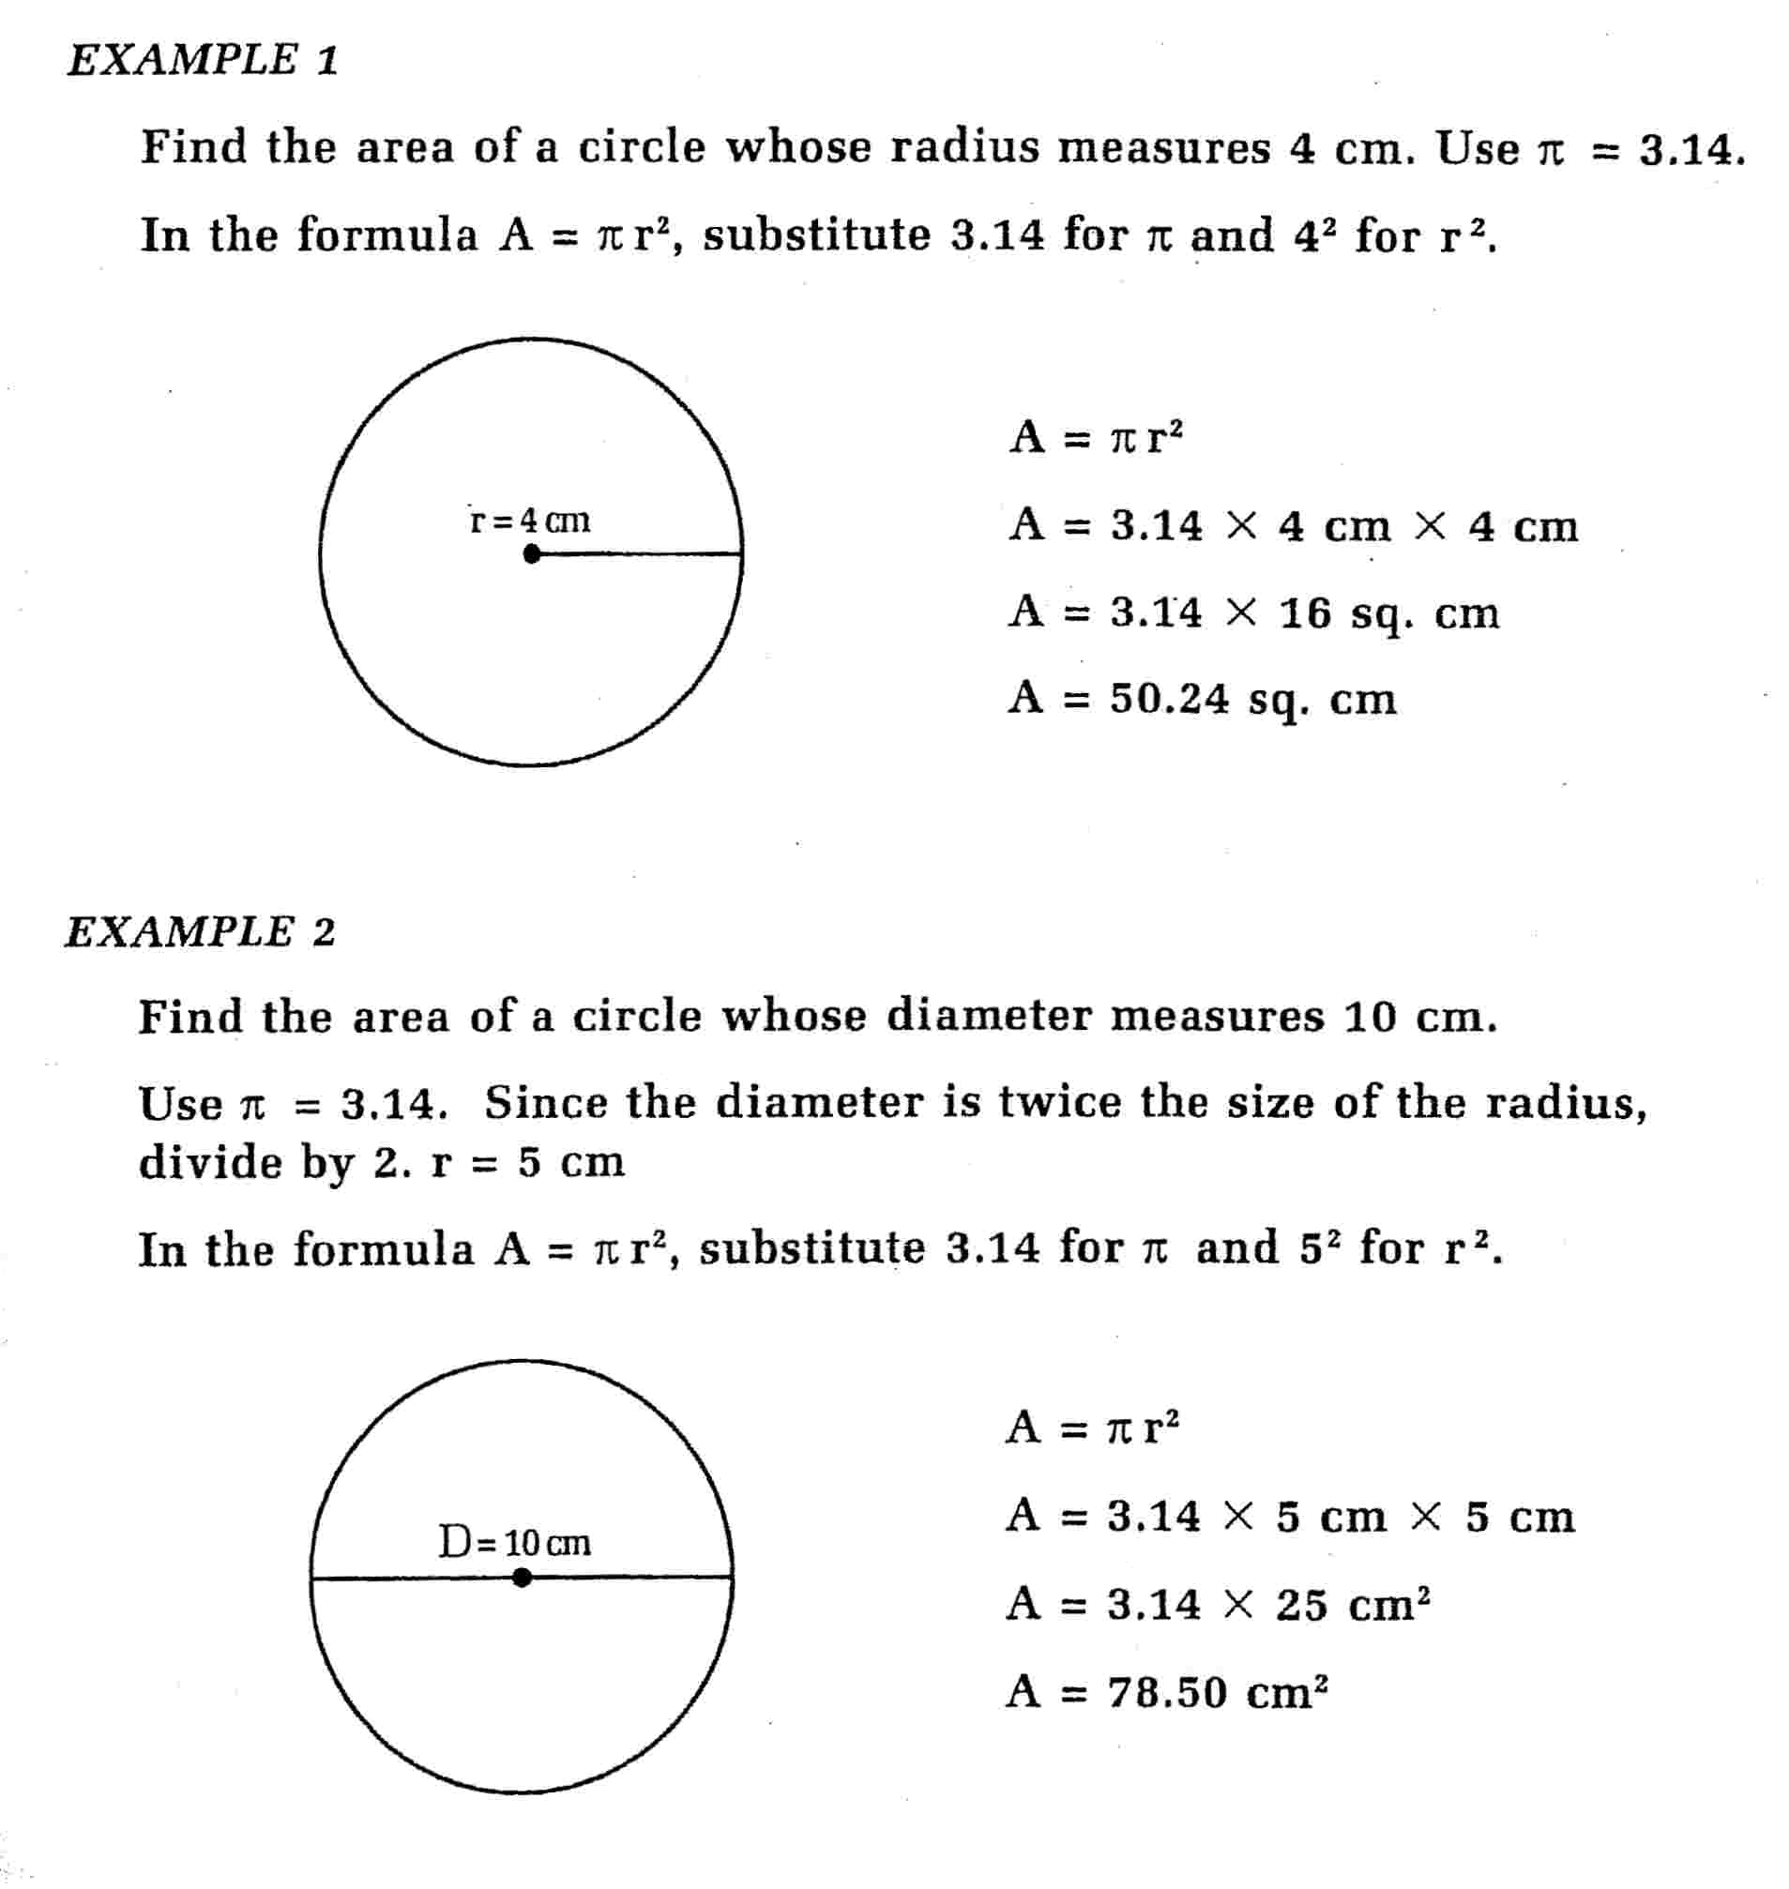

Your turn…

Directions: Using your area formula. Calculate the area of the following circles. Start with your formula and then follow all steps showing all your work.

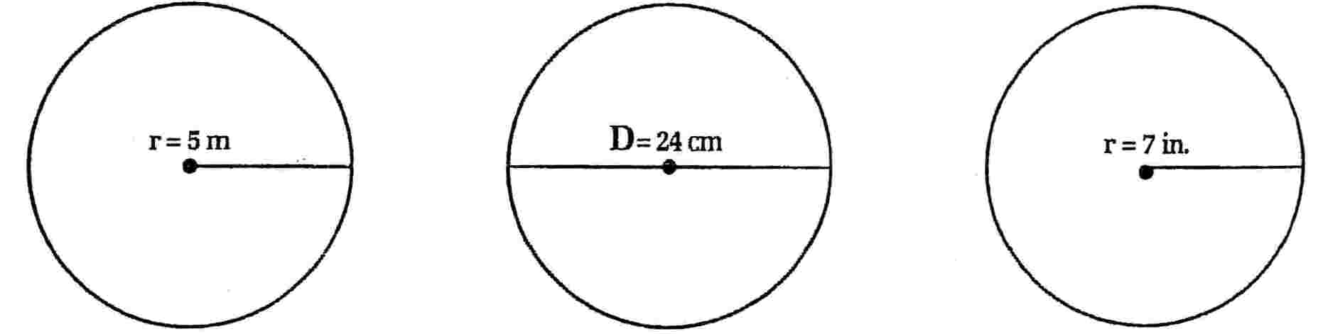

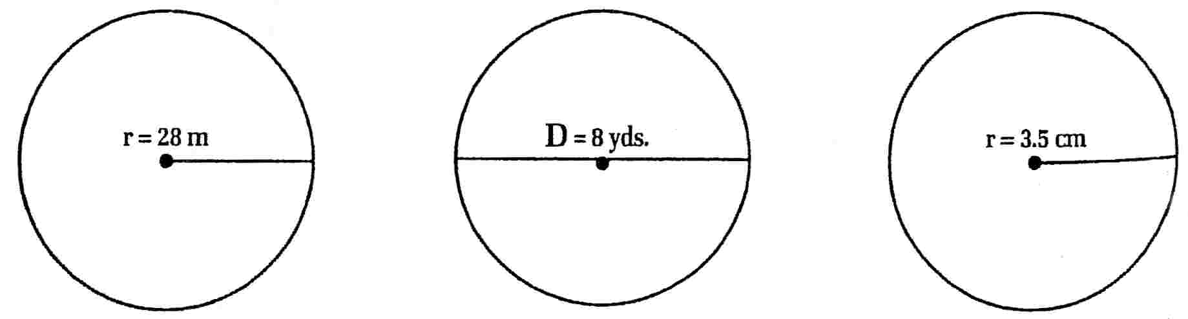

Directions: Answer the following word problems. When asked, start with your formula and then show all your work.
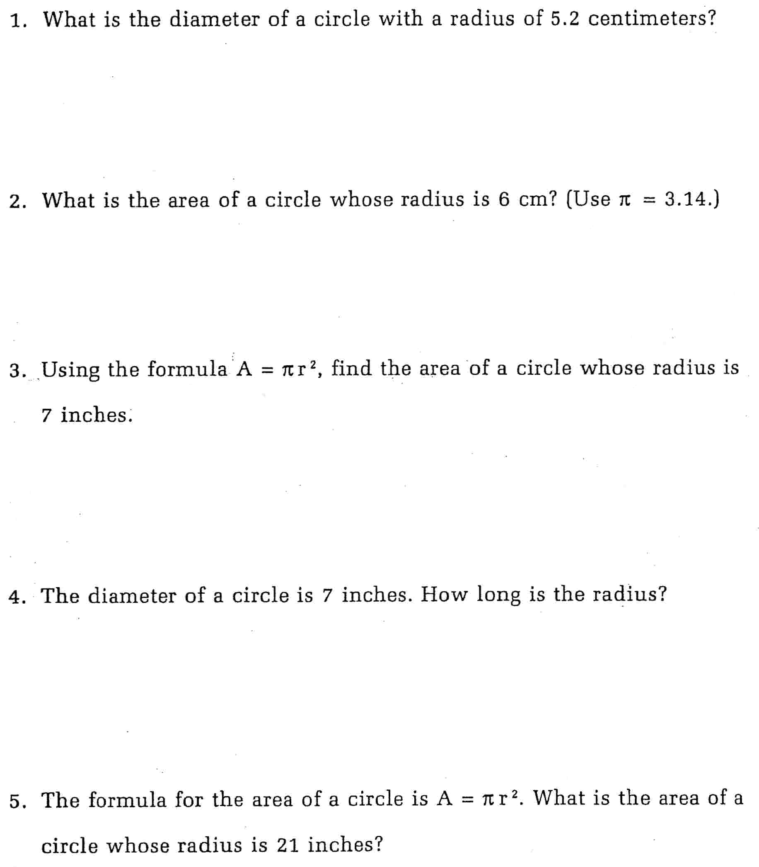

Directions: Solve the following area AND circumference problems. Start with your formula and then show all your work.

