Math 7 – Unit 6.5
- Exponents and Brackets

6.5 – Exponents and Brackets

Exponents are a short hand way of expressing a large number in a simple form. The exponent is expressed as a small number to the top and right of the “base” number.
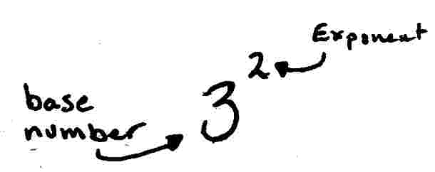

The exponent, tells us to multiply the base number BY ITSELF a certain number of times.

For example; 3² tells us to multiply the base number (in this case “3”) by itself, two times. Not two times three, but three times itself, twice;
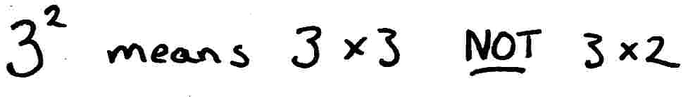

Your turn…

Directions: Write out the following exponent terms in expanded form. You don’t have to solve, simply write out what each expression means. The first two have been done for you.
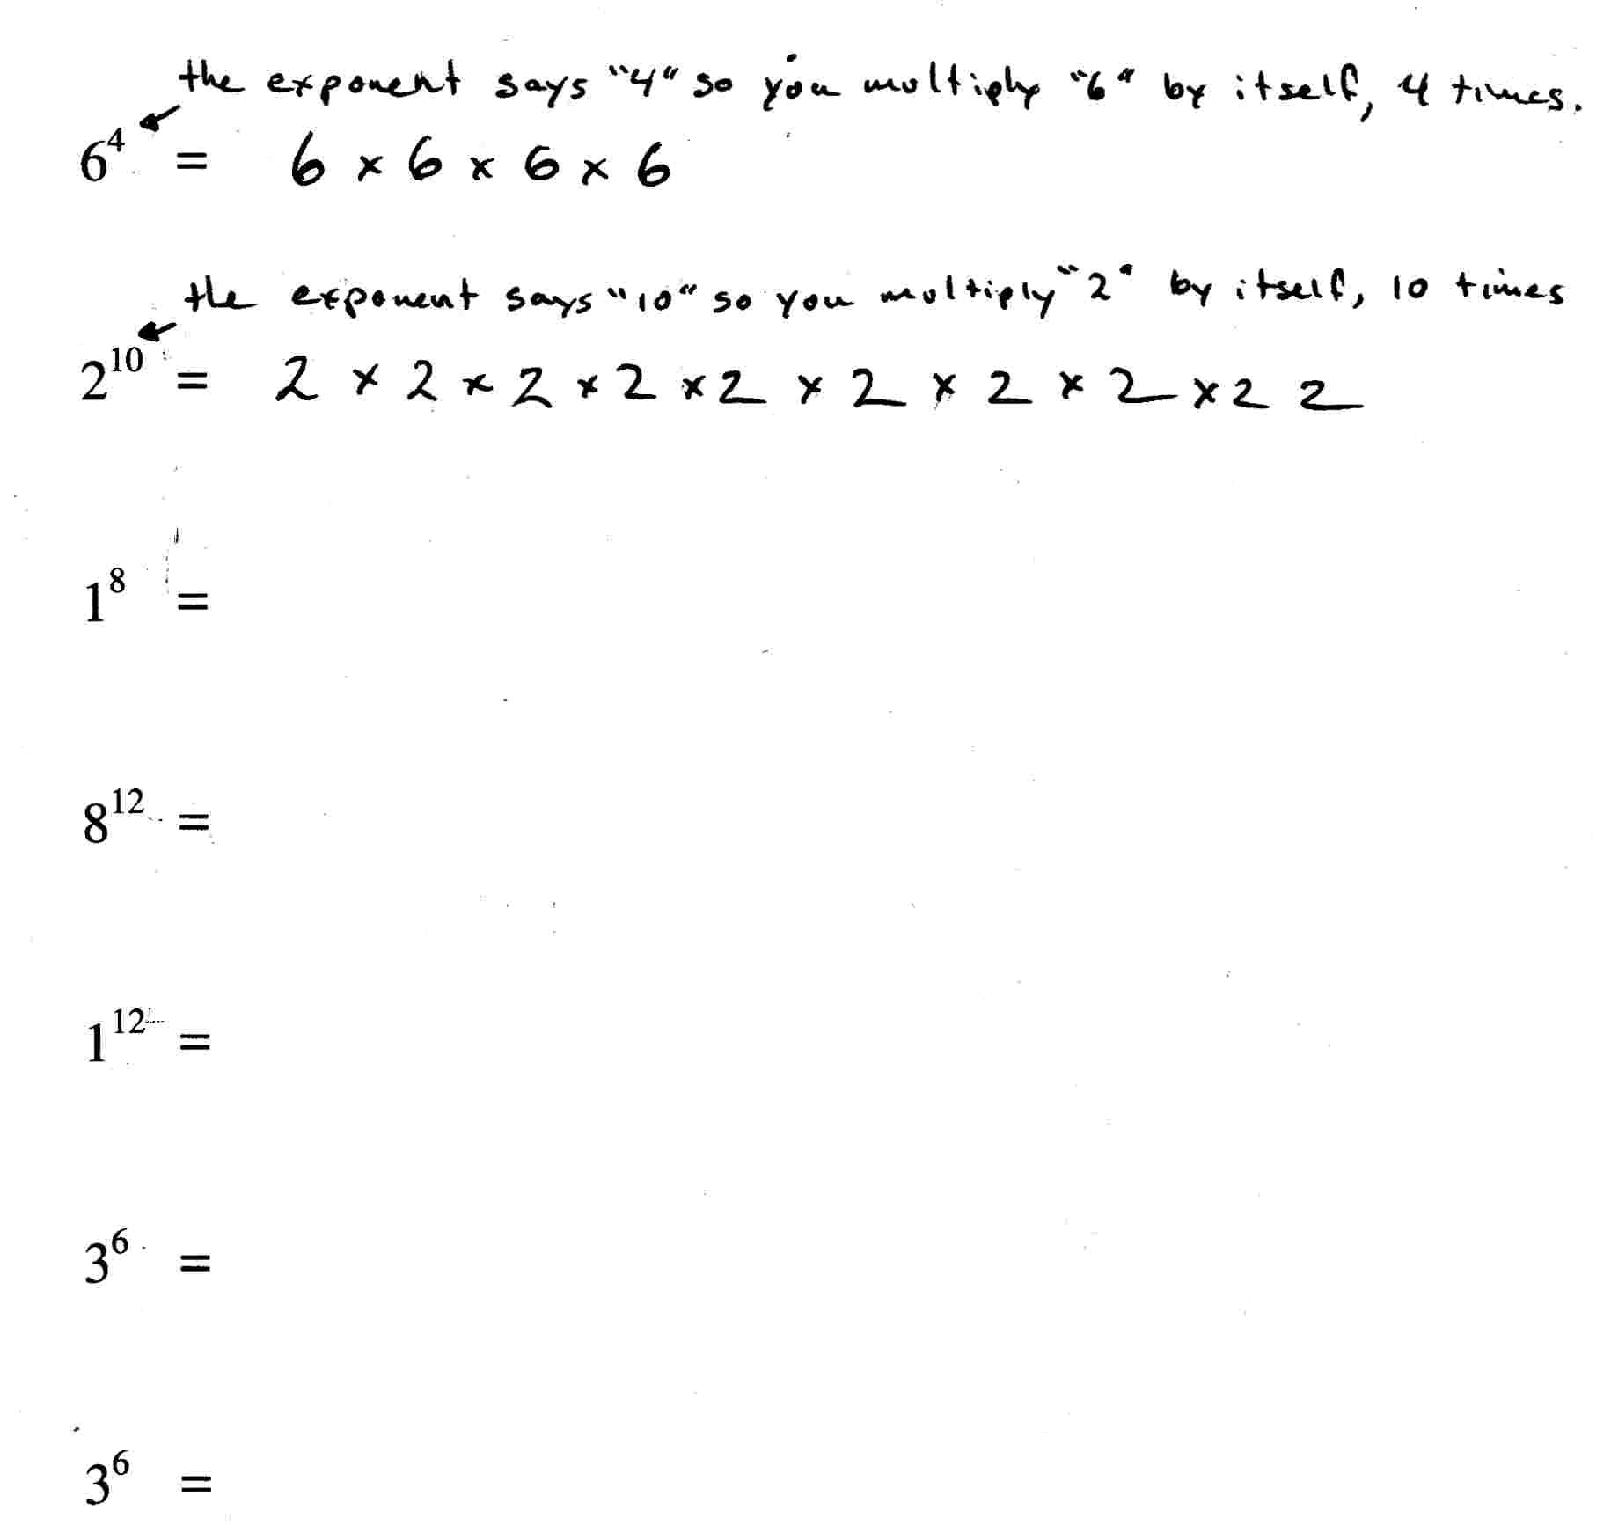

In algebra, brackets are used to tell the person to solve what is within the brackets first.
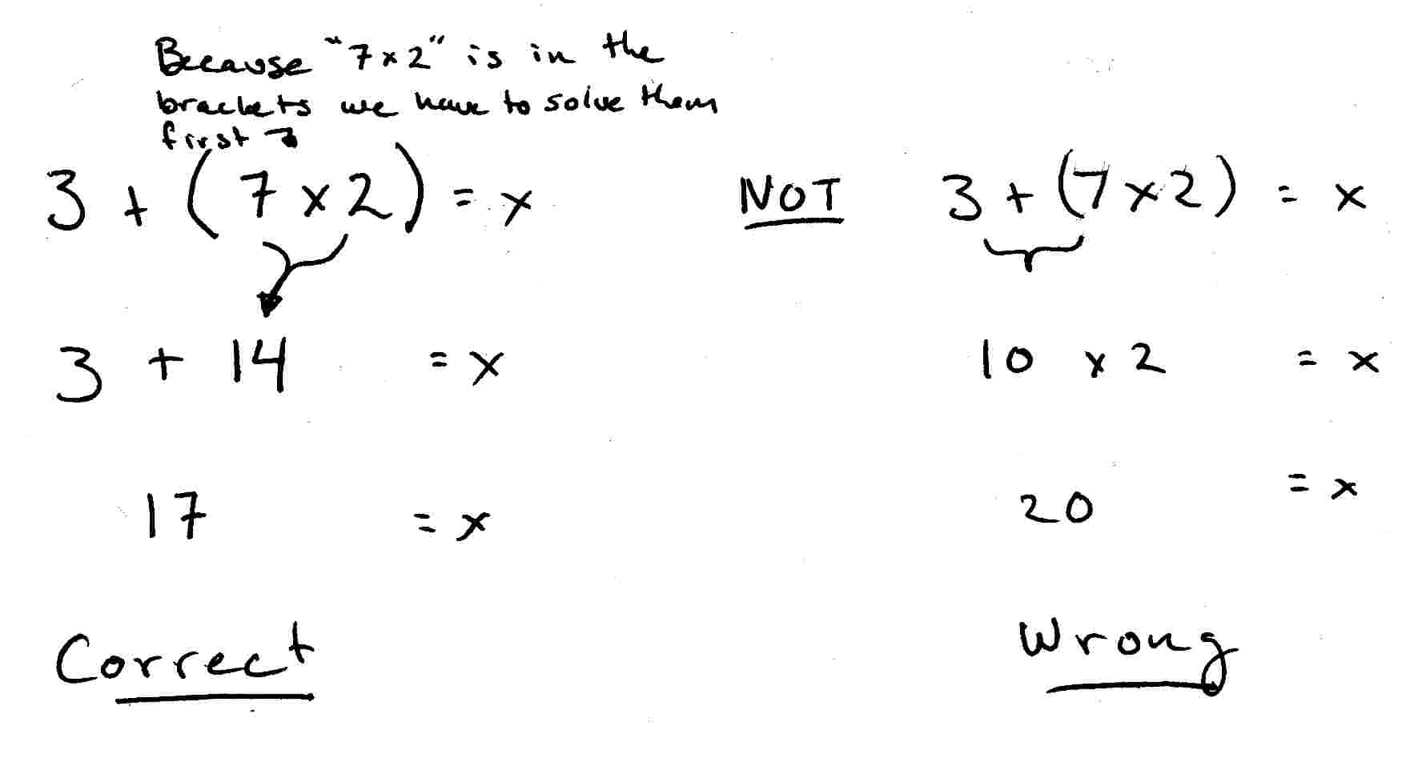
For example;

Your turn…

Directions: Solve the following equations by solving what is in the brackets first. The first one has been done for you.
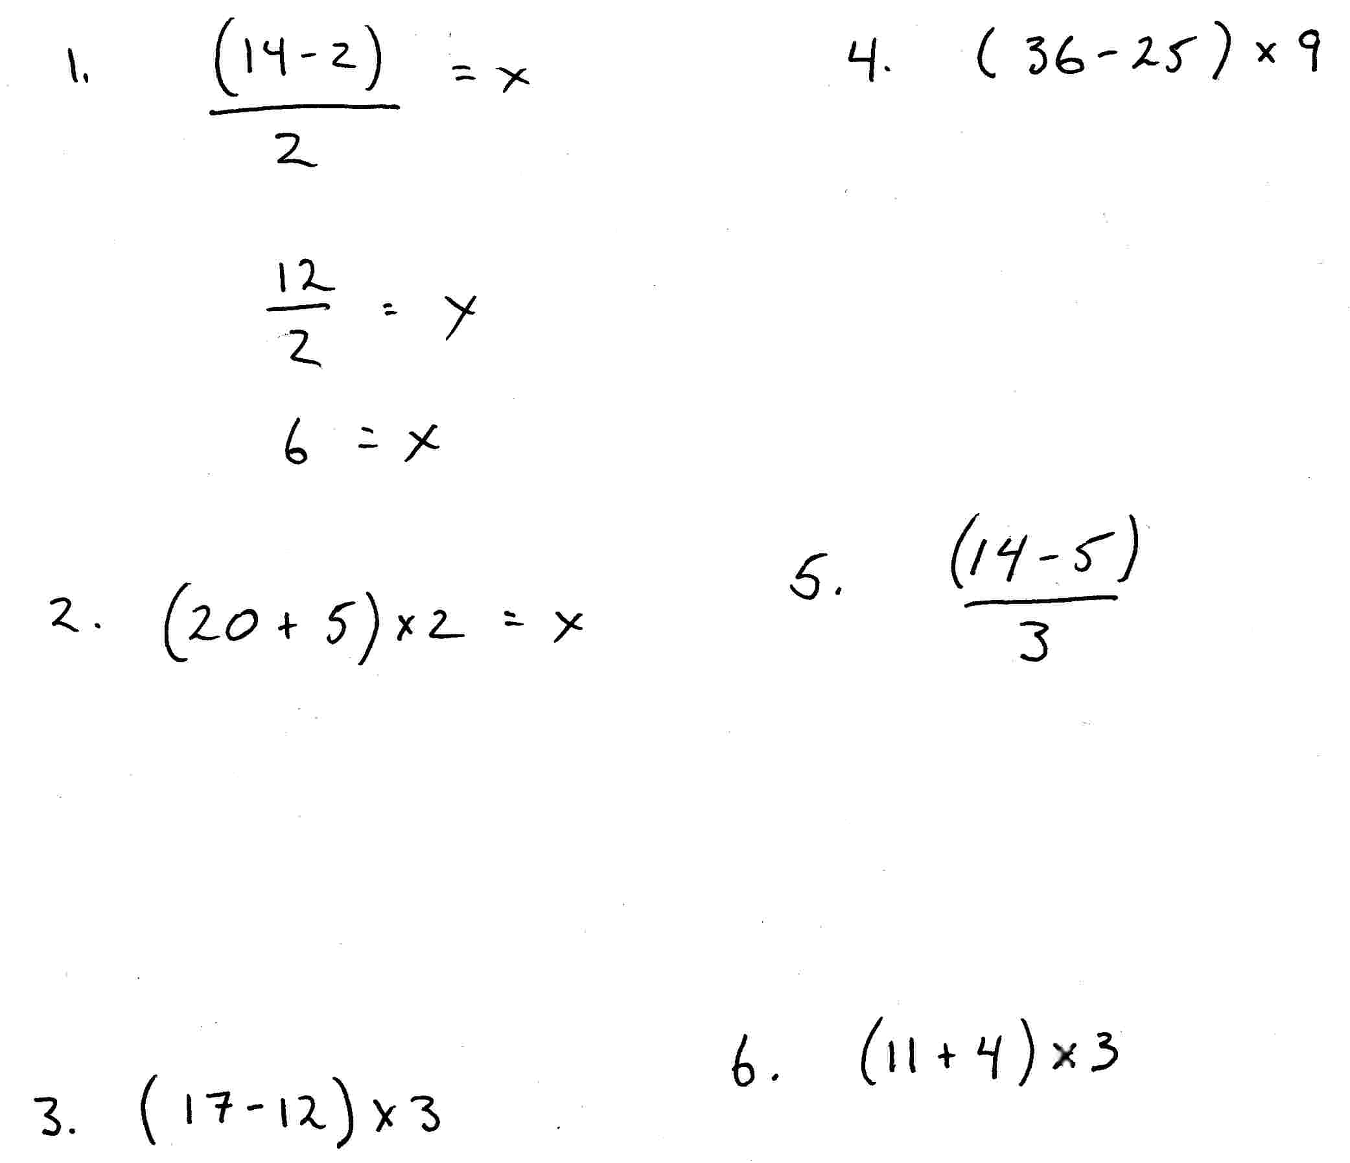

*Now create 5 equations of your own that make use of brackets. Once the equation has been made, show all your steps and solve that equation.

