Math 7 – Unit 5 Review

Lesson 5.8 – Unit Review

- Express the number of circles to triangles as a ratio as a fraction. Reduce to lowest terms if possible.
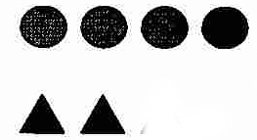

- Express the number of diamonds to triangles as a ratio as a fraction. Reduce to lowest terms if possible.

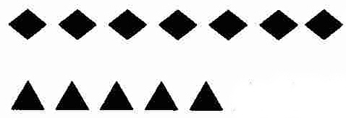

- Express the number of squares to triangles as a ratio as a fraction. Reduce to lowest terms if possible.

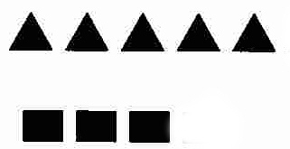

- Solve the following ratio questions. SHOW ALL YOUR WORK FOR FULL MARKS!!! (2 mks each)

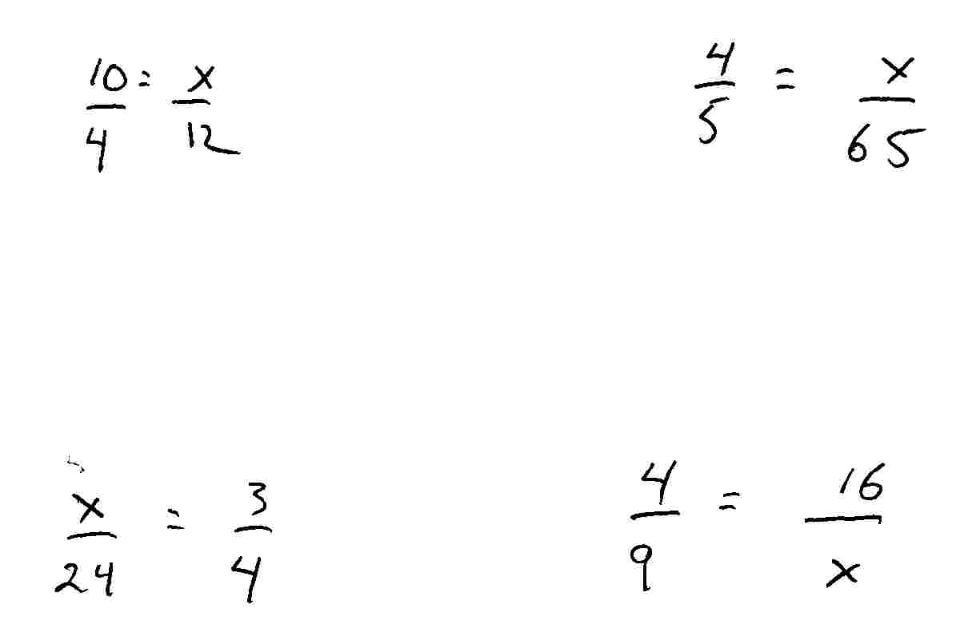

- Solve for the following word problems. Be sure to identify the ratio, formulate an equation, isolate the unknown, cancel and then solve. SHOW ALL YOUR WORK FOR FULL MARKS!!! (2 mks each)

On a map, 3 cm represents 12 kilometers. How many kilometers would represent a distance 15 centimeters on the map?

Sarah swims an average of 3 kilometers every 2 days when she’s in training. At this rate, how many days will she take to swim 60 kilometers?

On a map 2 cm represents 15 kilometers. How many centimeters would represent a distance 120 kilometers long?

BJ wants buy 2 Xbox games off of eBay for $25.00. How much would BJ have to pay if he wanted to buy 12 games off of the same site?

Directions: Use the following tables to help formulate ratios to solve the following proportional problems. SHOW ALL YOUR WORK FOR FULL MARKS!!!

12 inches (in) | = | 1 foot (ft)
3 feet | = | 1 yard (yd)
36 inches | = | 1 yard
5,280 feet | = | 1 mile (mi)

16 ounces (oz) | = | 1 pound (lb)
2000 pounds (lb) | = | 1 ton (ton)

8 fluid ounces (fl. oz.) | = | 1 cup (c.)
16 fluid ounces (fl. oz.) | = |  | 1 pint (pt.)
2 cups (c.) | = | 1 pint (pt.)
2 pints (pt.) | = | 1 quart (qt.)
4 quarts (qt.) | = | 1 gallon (gal.)

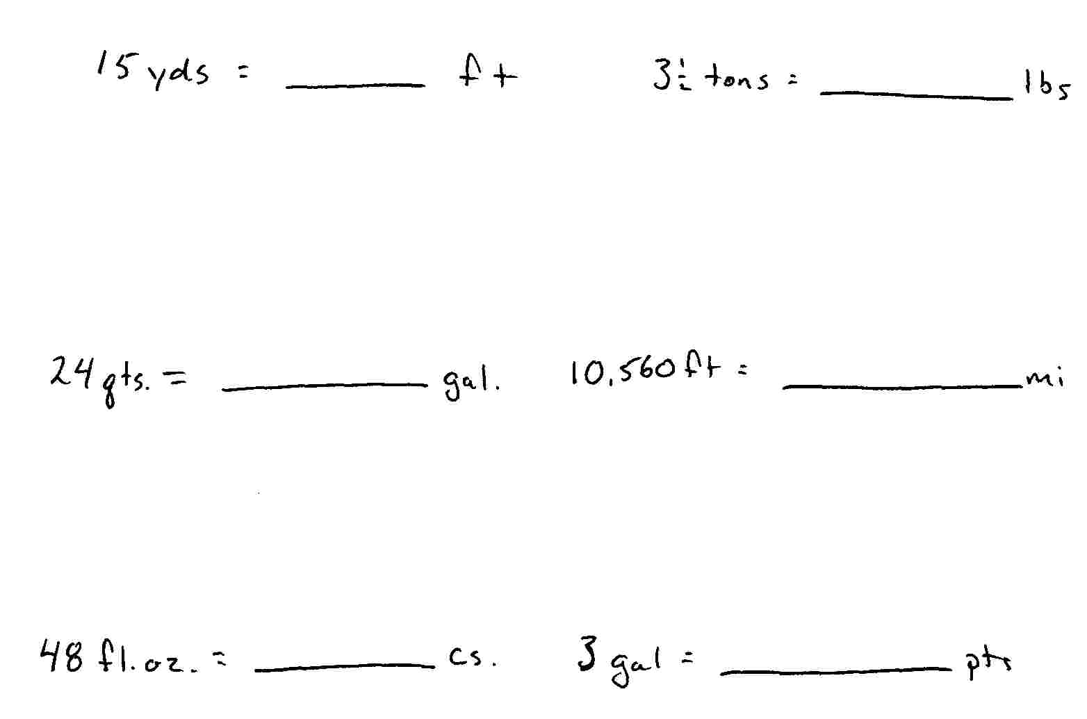

Directions: Using the metric conversion table provided, convert the following measurements;
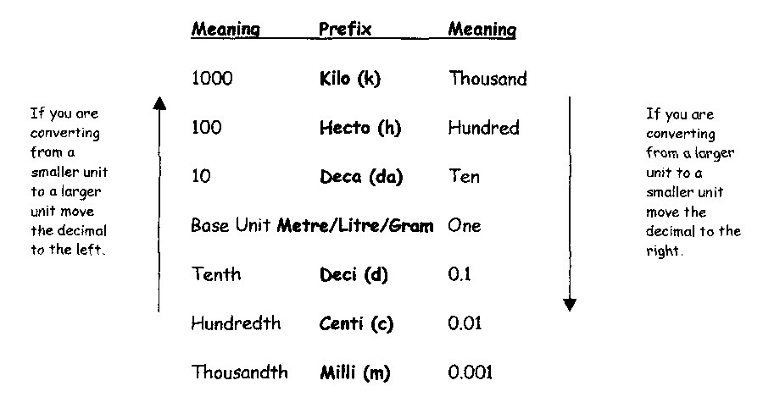

.056 hm = ________ cm 3200 dl = ________ kl

15 dm = ________ dam 62 dag = ________ mg

48 cm = ________ mm .0045 kl = ________ cl

97 hg = ________ mg 21 cm = ________ dgm

Directions: Convert the following time measurements.

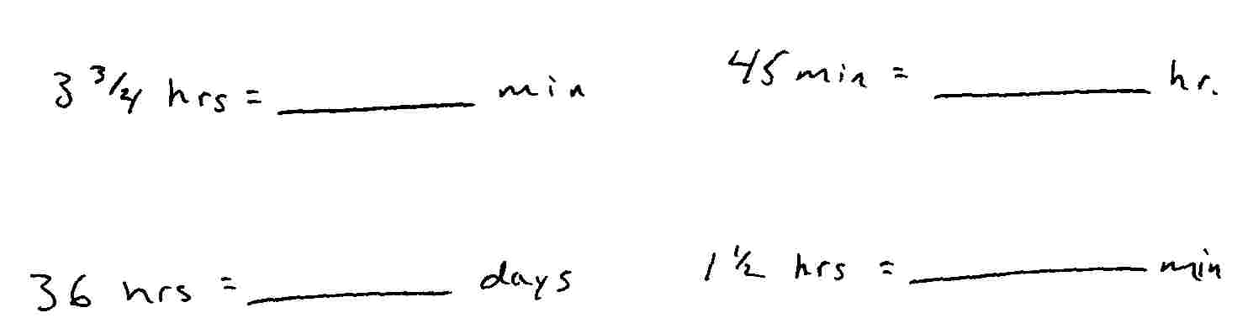

Directions: Read each problem carefully then solve.

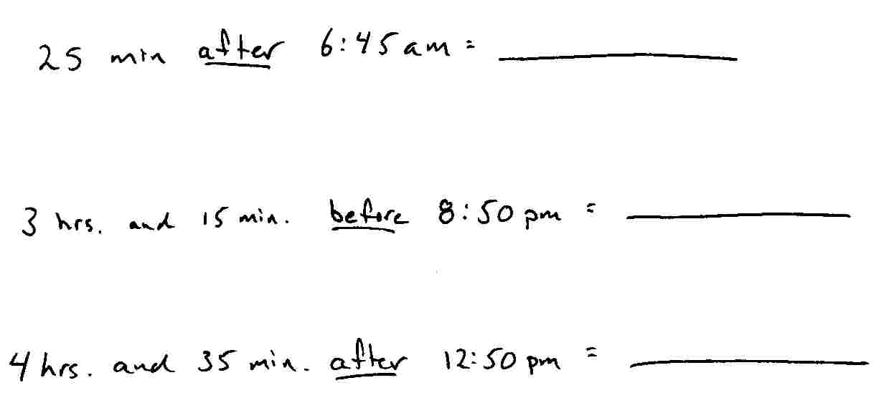

It takes Anders 1 ¾ hours to do his chores because he doesn’t pay attention the first time instructions are given and he has to keep asking what he has to do. If Anders started his chores at 1:15 pm, then what time did he finish?

Kevin showed up to math class ¾ of an hour late because he was too busy eating his lunch. If Math class started at 9:40 pm, what time did Kevin finally stroll into class?

If Natalya got a text from her boyfriend at 6:45 pm saying that he would be ½ hour late picking her up for their date, then what time would he pick her up?

