Math 7 – Unit 3
- Assignment 3.4 – Dividing Mixed Numbers

Assignment 3.4 – Dividing Mixed Numbers

Dividing mixed numbers is easy as long as you remember to covert the mixed numbers to improper fractions. Once you’ve converted the mixed numbers to improper fractions, simply take the reciprocal of one and change the divided by sign to a multiply.

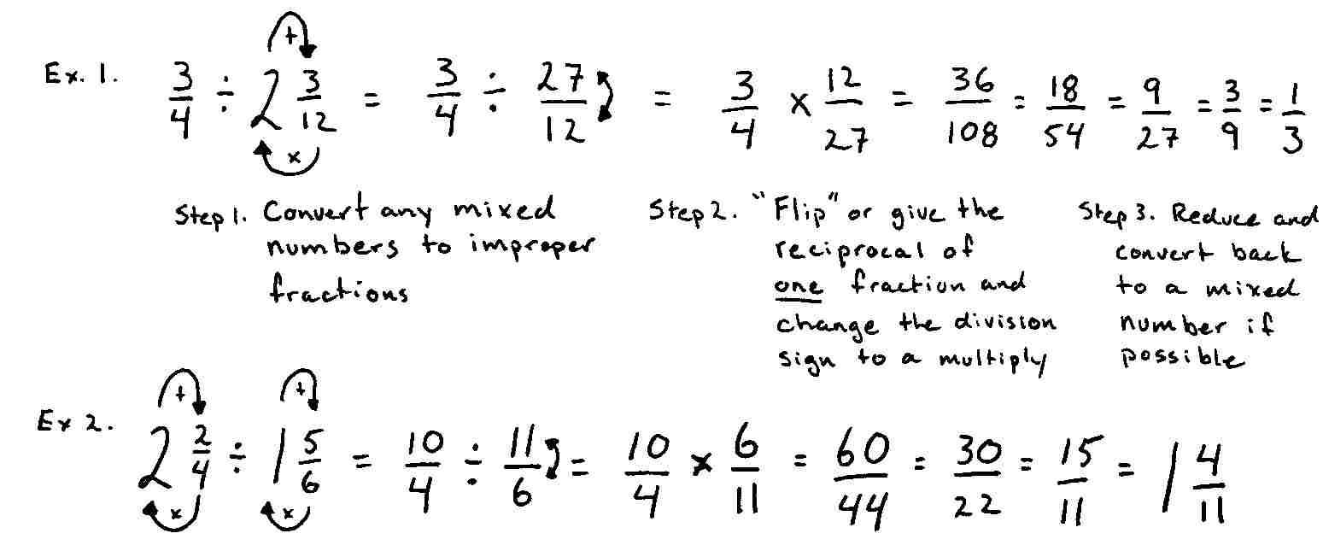

Your turn…

Directions: Change any mixed numbers to an improper fraction and then divide. Reduce and convert back to mixed numbers if possible. The first three have been done for you.

