Math 7 – Unit 2
- Assignment 2.7 – Dividing Fractions

Assignment 2.7 – Dividing Fractions

If you can multiply a fraction you can divide fractions. The simple trick is to re-format your equation by giving the reciprocal of the second fraction and then changing the division sign to a multiplication sign. The reciprocal of the fraction simply means to “flip” the numbers.
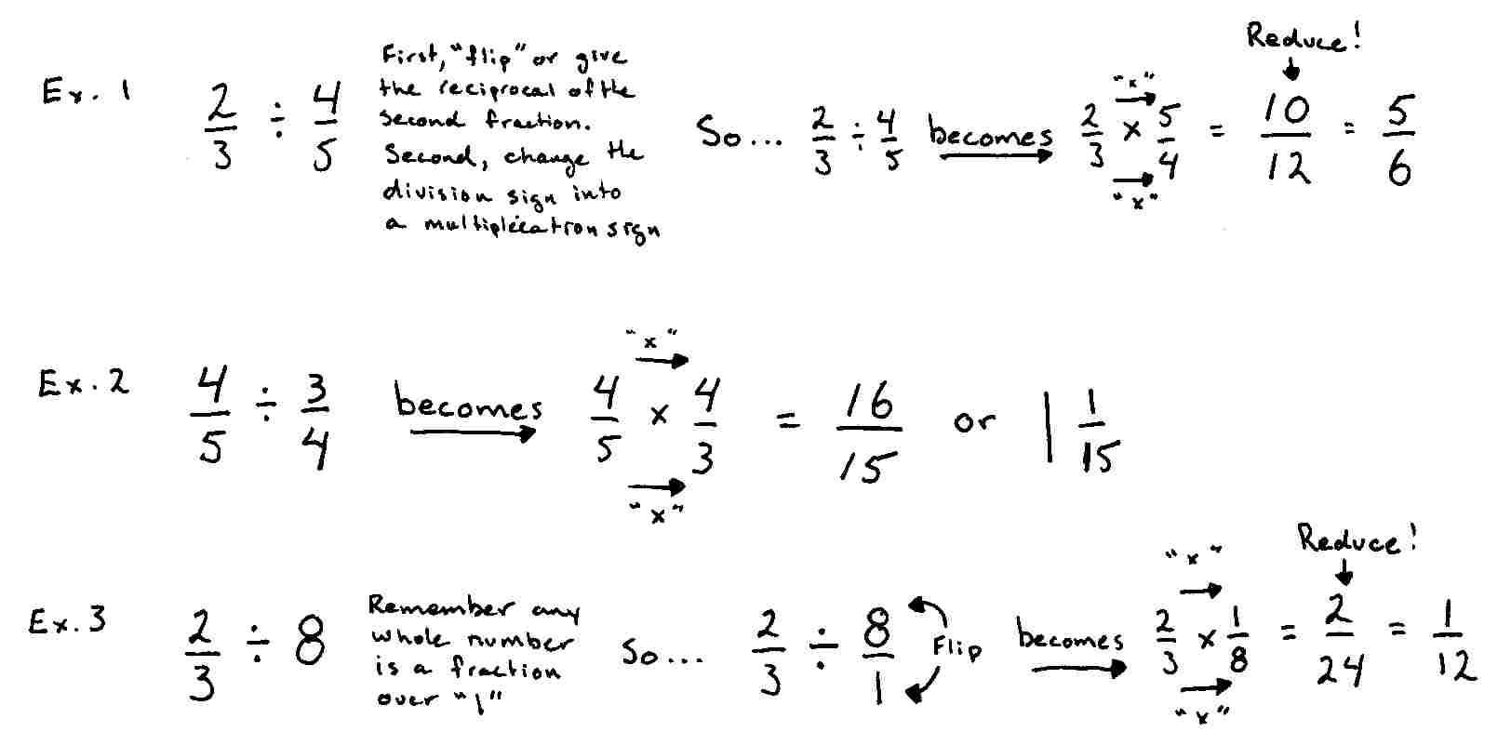

Your turn…

Directions: Find the reciprocal (the “flip”) of the following fractions. The first three have been done for you.
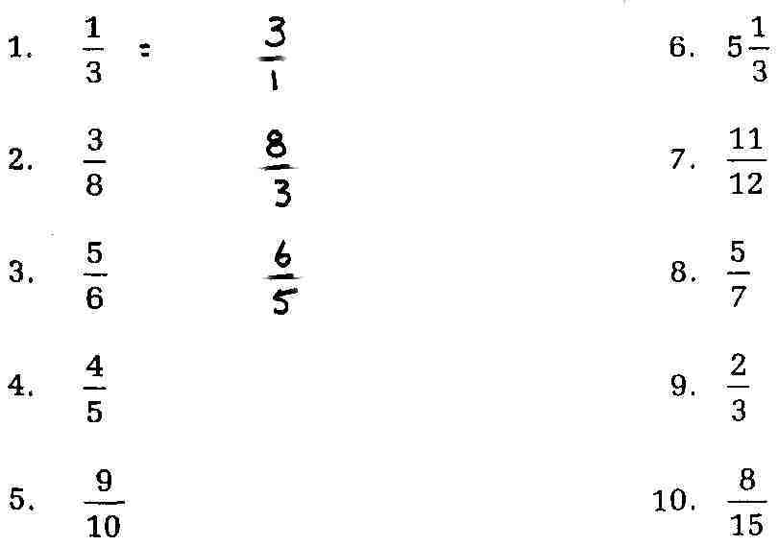

Directions: Divide the following fractions. SHOW YOUR WORK!
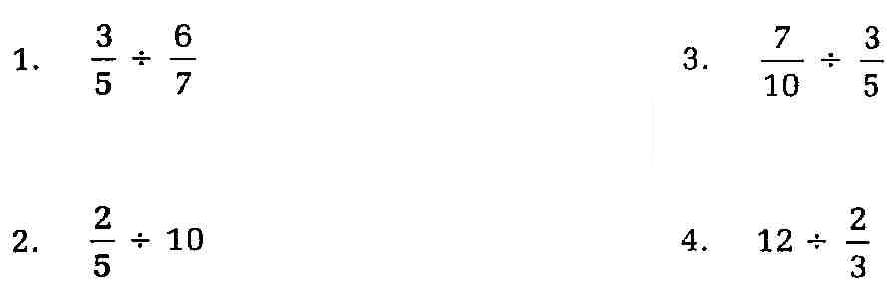

In order to divide mixed numbers, you must convert or re-format the mixed number into an improper fraction. Then “flip” the second fraction and multiply.

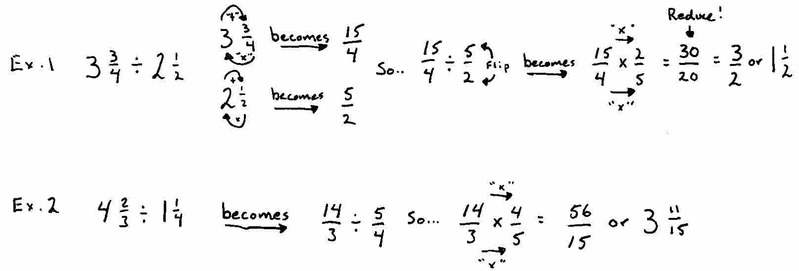

Your turn…

Directions: Convert the following mixed numbers into improper fractions then divide. SHOW YOUR WORK!

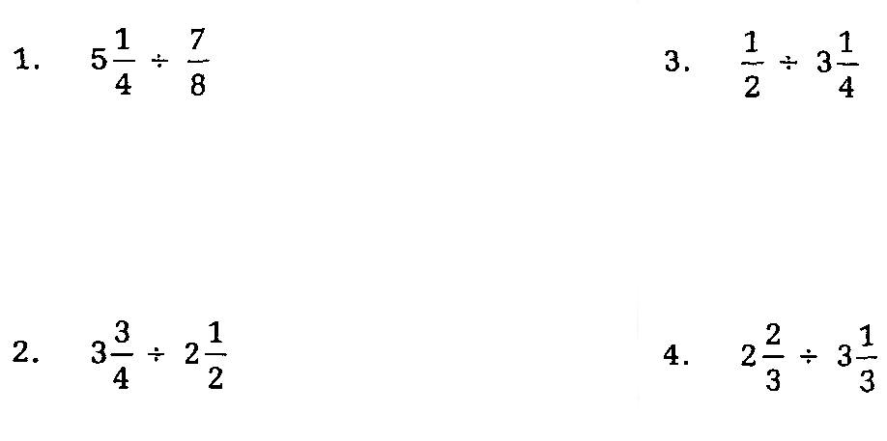

Directions: Divide. Convert any mixed number into an improper fraction first. SHOW ALL WORK!
