Math 7 – Unit 2
- Assignment 2.5 – Changing Mixed Numbers to Improper Fractions

Assignment 2.5 – Changing Mixed Numbers to Improper Fractions

A mixed number is a number that has a whole number and a fraction such as 2 ¾. In order to change a mixed number into an improper fraction, you simply multiply the denominator (bottom number) by the whole number, add the numerator (top number) and leave your answer over the bottom number. For example;
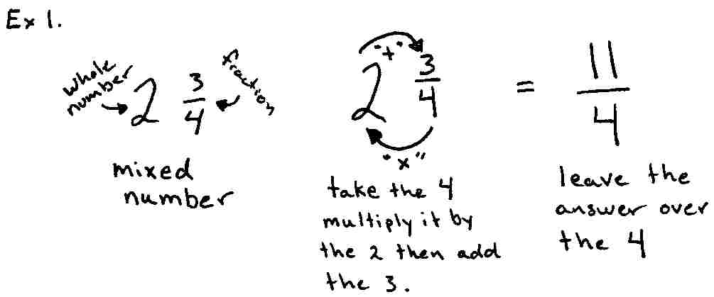

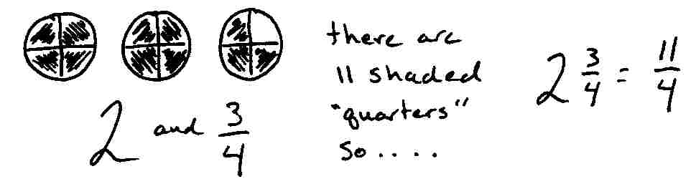

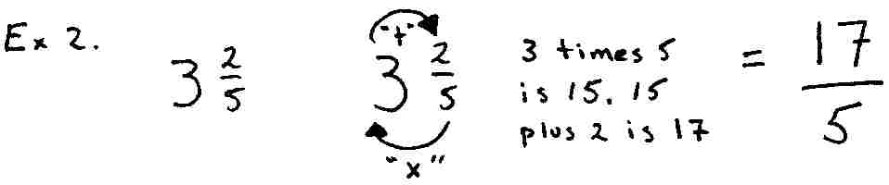

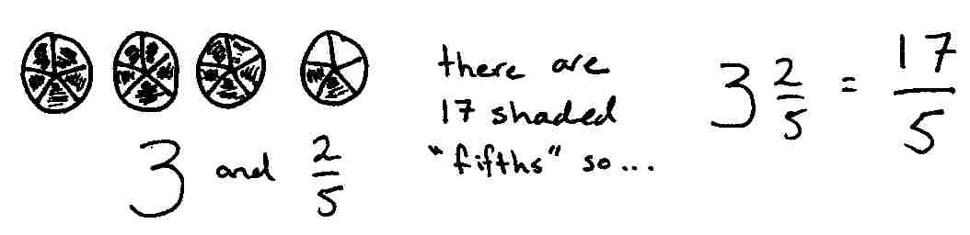

Your turn…

Directions: Change each mixed number to an improper fraction. The first two have been done for you.

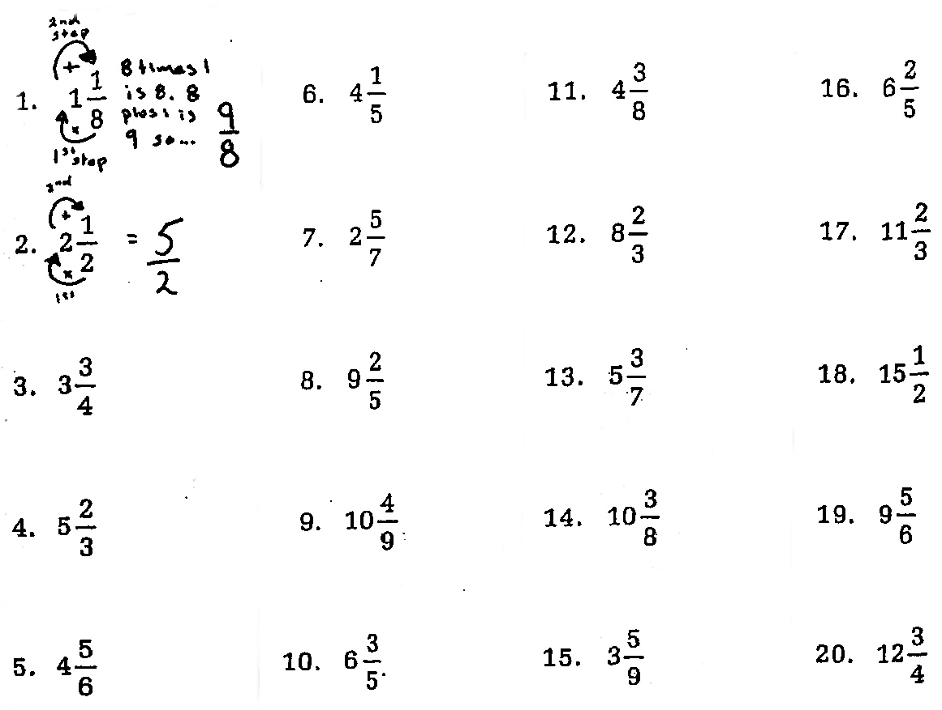

More practice

