Math 7 – Unit 2
- Assignment 2.4 – Changing Improper Fractions to Whole or Mixed Numbers

Assignment 2.4 – Changing Improper Fractions to Whole or Mixed Numbers

An improper fraction has a top number (numerator) that is larger than the bottom number (denominator). To change an improper fraction into a whole or a mixed number, simply divide the bottom into the top.

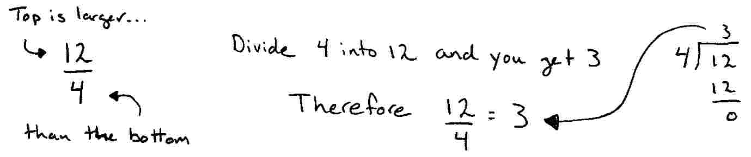

If the bottom does not divide evenly and you get a remainder, that remainder is what left of your original fraction, forming a mixed number.

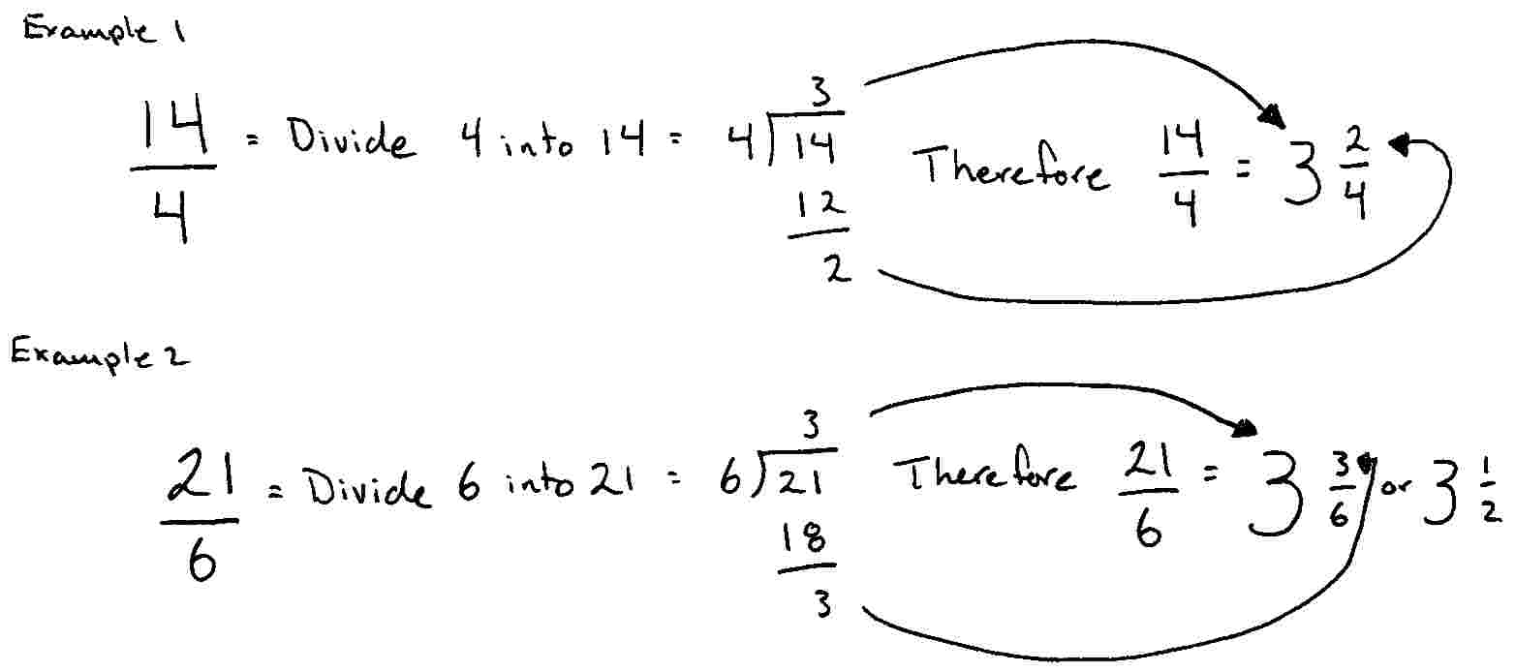

Your turn…

Directions: Change each improper fraction into a whole or a mixed number (reduce to lowest terms if possible). The first row has been down for you.

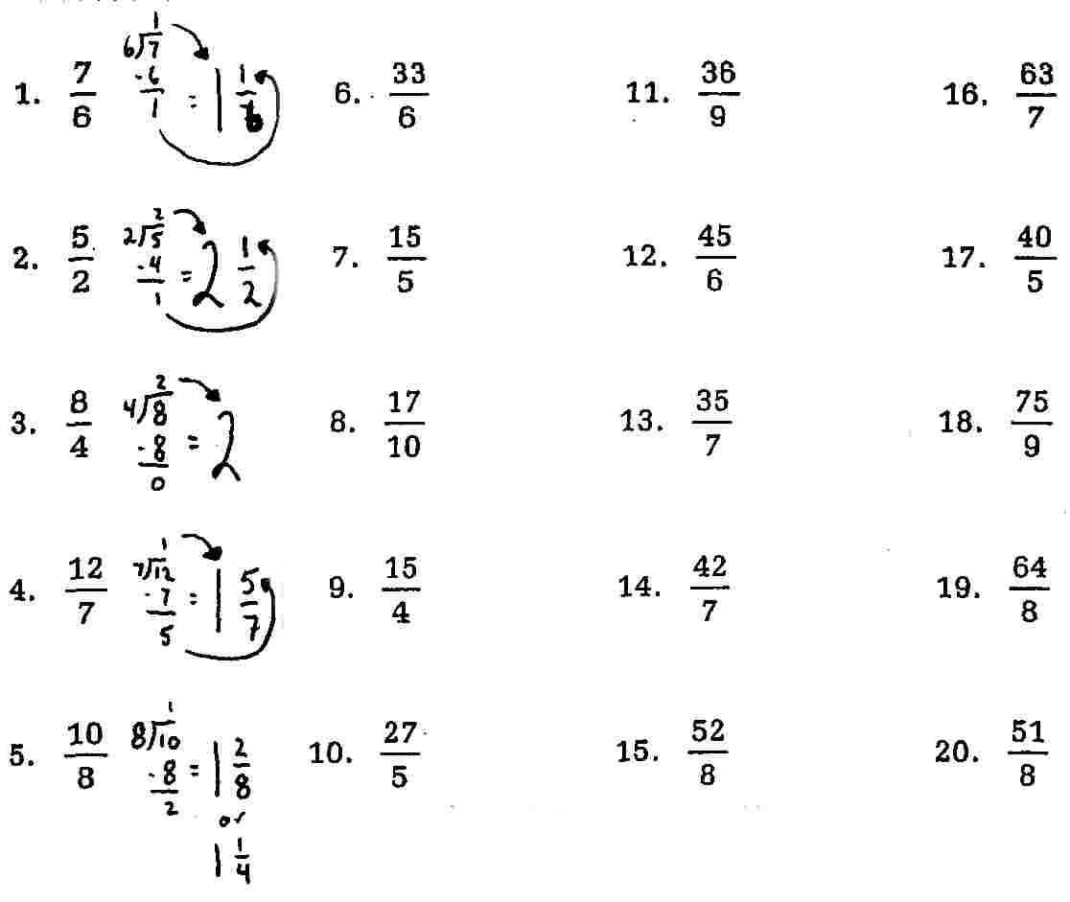

More Practice

